Create a dll file in vb6.0. which return sum of two integer passed by user.call that COM file in to your vb.net application

a.Now take input of two inreger from user using textbox and result should be displayed on third textbox.

**Solution:**

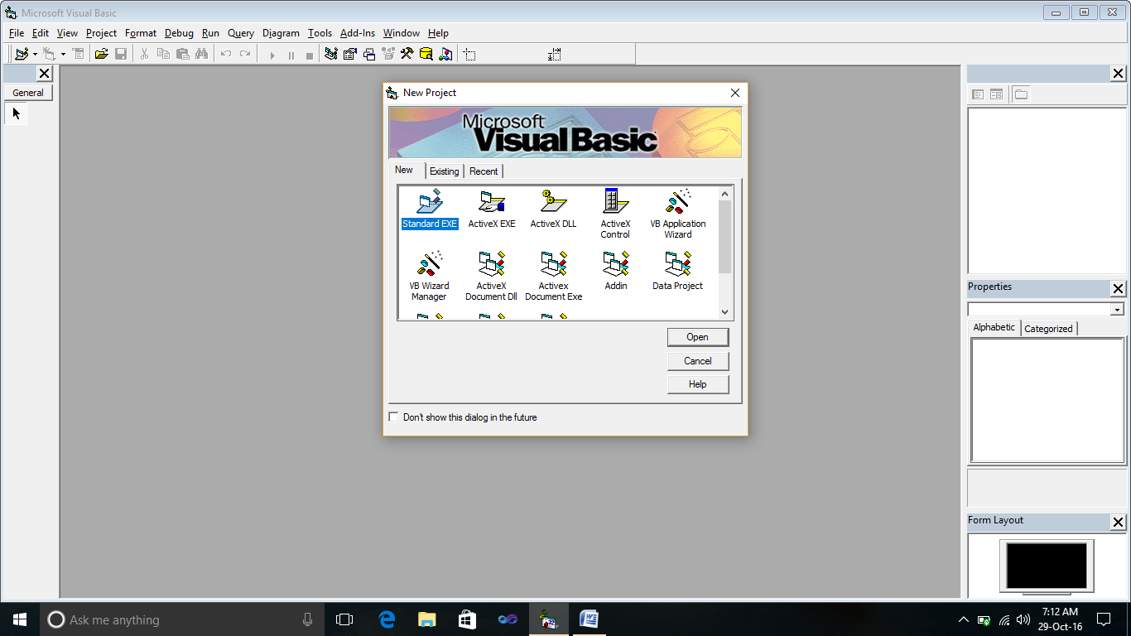

1. First create a Activex DLL file in visual basic 6.
2. Then write a code to take two number from user it create Class file.

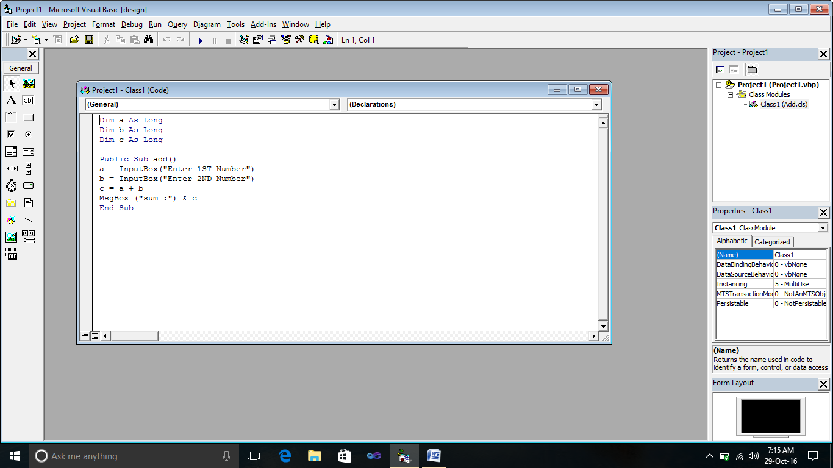

1. After save this file.
2. Go to File menu and select make project.dll and save it in new folder.
3. After that create a new project in Visual basic 10 and select windows form

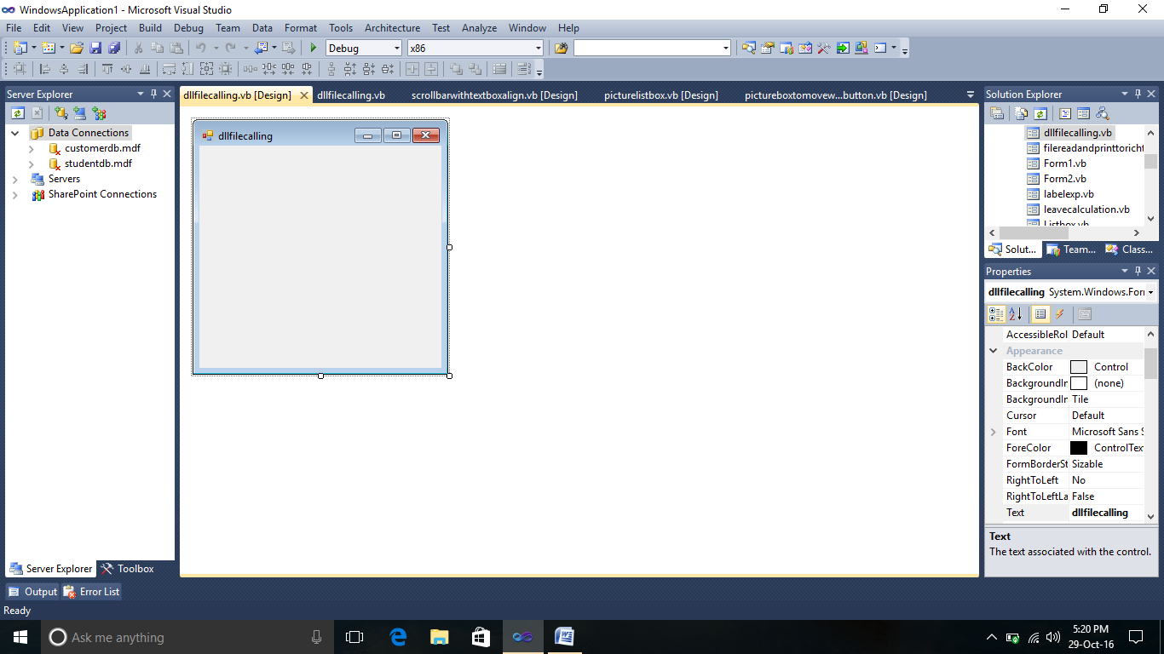

1. Then create one form and go to coding page of that form.
2. Then create a object of dll class file in this form

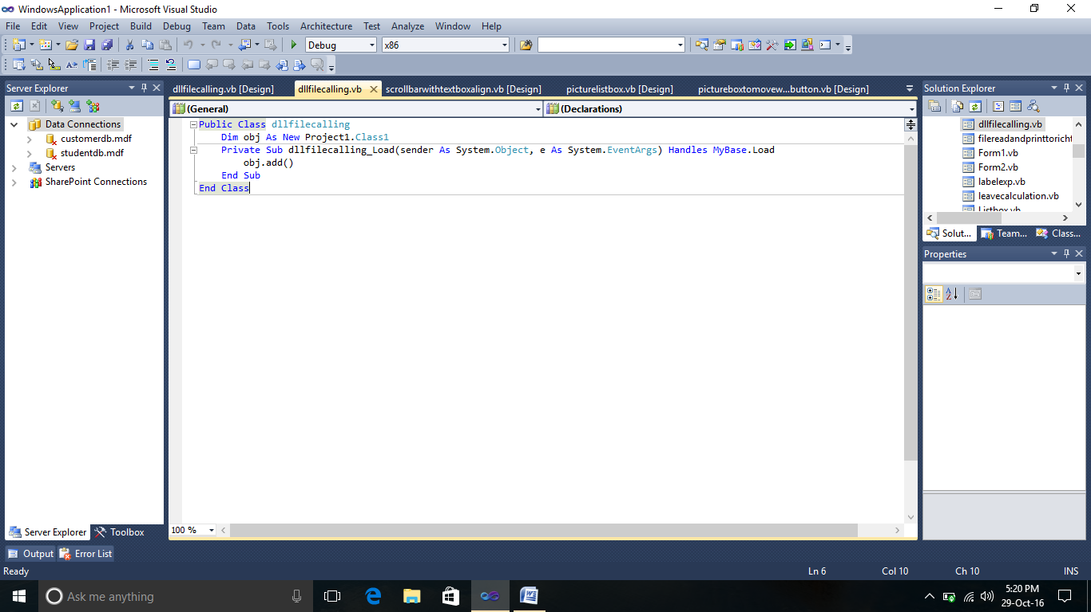

1. Then Go to Project menu and Select the Add References option
2. Then give the Reference of your dll file in this project.

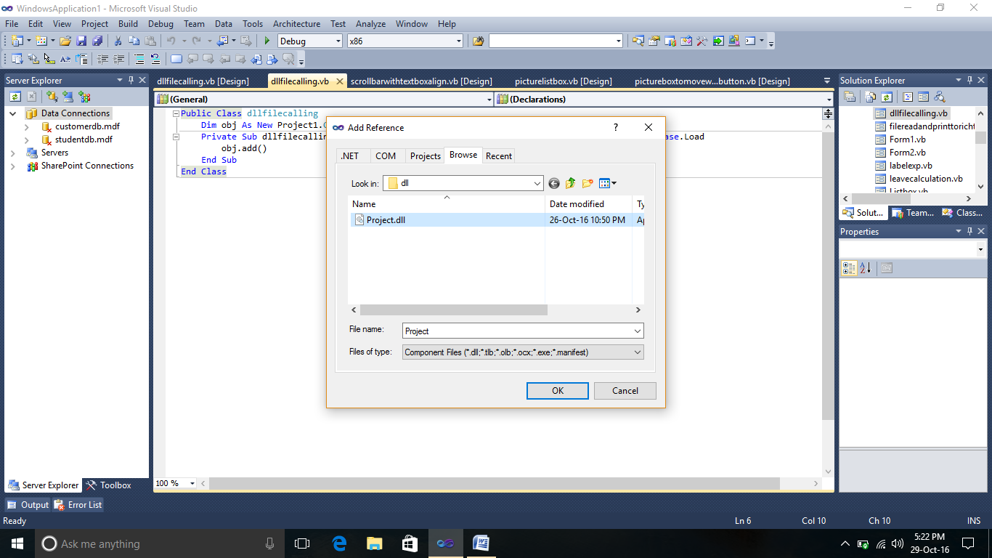

1. Then Execute it.
2. After run it will ask for input

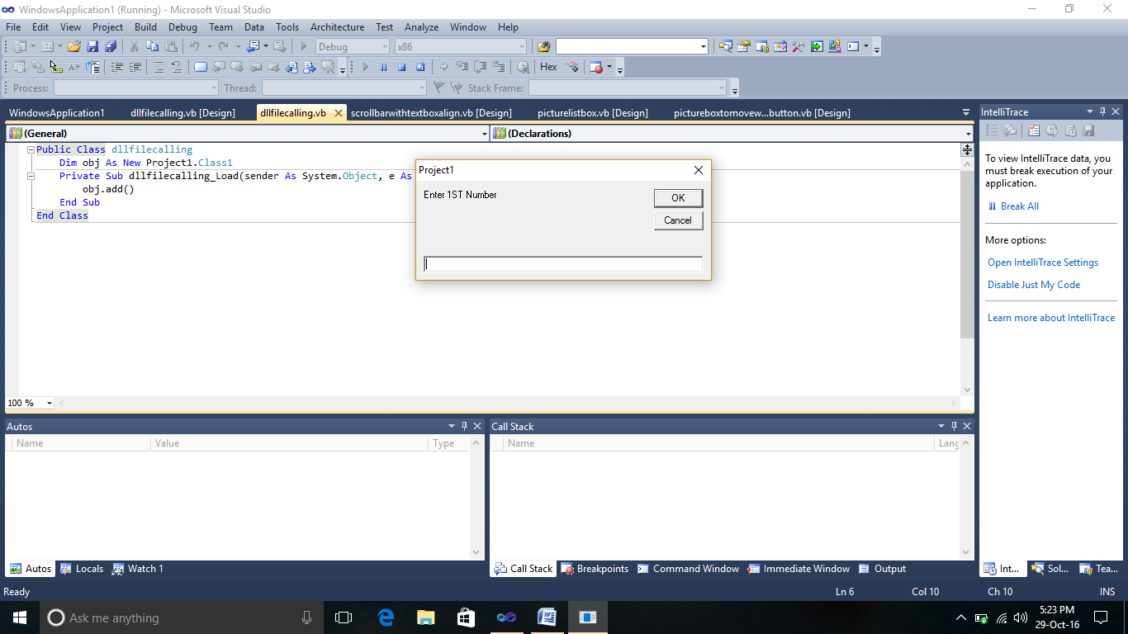

1. Output will be like this

